 | Industry: Vertical Farming  Buyer Persona: Finance Director, Head of Finance, Controller, Accountant  Product: Ambient's Enterprise Software Platform for Financial Management  Author: Ivan Damnjanovic  Publish Date: May 31, 2023
Transforming Financial Management
Transforming Financial Management for Vertical Farms Farms: A Case Study

Introduction
In this case study, we will explore how Ambient Systems can benefit your vertical farming business by revolutionizing your financial management processes. Discover how our advanced software platform can help you optimize financial planning, streamline reporting, and unlock actionable insights from your financial data, ultimately driving your business towards greater success.

The Story of Vertical Farming Businesses  Farmers intuitively understand the challenges and complexities of operating a vertical farming business. Your goals include maximizing yields, ensuring sustainability, and delivering high-quality produce to your customers. However, you also recognize that efficient financial management is crucial for achieving these objectives and maintaining a competitive edge in the industry. |  | 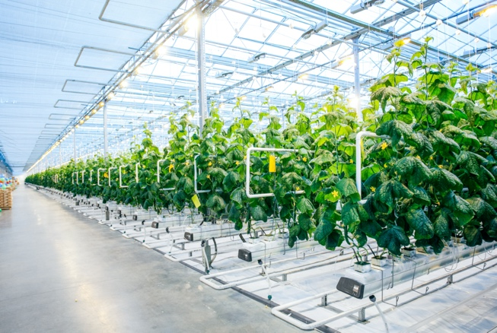
The Challenges of Financial Management in Vertical Farming |  | In your journey to success, you have encountered various challenges in managing your finances effectively. These include fragmented data and system integration, time-consuming forecasting processes, limited data visualization and reporting capabilities, and the incompatibility of legacy systems. These challenges hinder your ability to make data-driven decisions, optimize resource allocation, and track your financial performance accurately.

Reasons Why Your Farm Should Choose Ambient Systems for their Financial Management Platform | The answer to your financial management challenges lies in Ambient Systems. By adopting our enterprise software platform, you can unlock a range of benefits that will propel your business forward.  1. Accurate Financial Data: Ensure the integrity and accuracy of your financial data, enabling reliable reporting and analysis for better decision-making.  2. Streamlined Processes: Streamline your financial workflows, saving time and reducing manual errors, allowing you to focus on core business operations.  3. Comprehensive Data Visualization: Gain valuable insights through advanced data visualization, empowering you to interpret financial information more effectively and drive strategic initiatives.  4. Compatibility with Legacy Systems: Seamlessly integrate Ambient Systems with your existing systems, leveraging your historical data and ensuring compatibility with modern financial management practices.  5. Scalability and Adaptability: Ambient Systems grows with your business, offering the flexibility to scale operations and adapt to evolving industry demands.
How Ambient Systems Responds to Your Needs | Ambient Systems is designed to address the specific pain points faced by vertical farming businesses. Our core features, including data integration and consolidation, data visualization, automation of repetitive tasks, activity tracking, and data import/export, work together harmoniously to transform your financial management processes.

The Results
By adopting Ambient Systems, you can achieve remarkable outcomes:

1. Enhanced Financial Performance: Optimize your financial performance through accurate forecasting, streamlined budgeting, and improved revenue management, resulting in increased profitability.
2. Informed Decision-Making: Make data-driven decisions with confidence, leveraging comprehensive financial insights and analytics, ultimately enabling you to seize growth opportunities and mitigate risks effectively.
3. Improved Efficiency and Productivity: Automate repetitive financial tasks, freeing up valuable time and resources for your team to focus on strategic initiatives and business growth.
4. Transparency and Accountability: Foster transparency in financial management, ensuring accountability among stakeholders and building trust with investors and partners.
5. Competitive Advantage: Gain a competitive edge by leveraging advanced financial management capabilities provided by Ambient Systems, positioning your farm as a leader in the vertical farming industry.

Call-to-Action
Ready to transform your financial management processes?
Take the next step by contacting our dedicated team today. Experience the power of Ambient Systems firsthand and unlock the potential for greater financial success in your vertical farming business.

